**UNIVERSITY OF ENGINEERING AND**

**TECHNOLOGY LAHORE**



**Assignment # 1**

**DC Motor Drive**

**Course Title: Control of Electric Machine Drives**

**Course Code: EE 535**

**Submitted to:**

**Dr. Syed Abdul Rahman Kashif**

**Assistant Professor**

**Submitted by:**

**Muhammad Shamaas**

**ID # 2018-MS-EE-4**

**Date of Submission: 19 December 2019**

**DEPARTMENT OF ELECTRICAL ENGINEERING**

**DC Motor Model**

A simulation model of the permanent-magnet DC motor was built. The armature voltage $u_{a}$ and the load torque $T_{L}$ are the inputs of the model. The armature current $i_{a}$ and the angular rotor speed ωM are the outputs of the model. The DC Motor Dynamic Equations are

$$L_{a}\frac{di_{a}}{dt}=u_{a}-R_{a}i_{a}-k_{f}ω_{M}$$

$$J\frac{dω_{M}}{dt}=k_{f}i_{a}-T_{L}$$

1. **Per unit Current and per unit Speed**



Figure : Per unit current and speed

DC Model Transfer Function

$$L_{a}si_{a}(s)=u_{a}(s)-R_{a}-k_{f}ω_{M}(s)$$

$$Jsω_{M}(s)=k_{f}i_{a}(s)-T_{L}(s)$$

$$i_{a}\left(s\right)=\frac{su_{a}(s)}{s^{2}L_{a}+R_{a}s+\frac{k_{f}^{2}}{J}}+\frac{\frac{k_{f}}{J}T_{L}(s)}{s^{2}L_{a}+R_{a}s+\frac{k_{f}^{2}}{J}}$$

$$ω_{M}(s)=\frac{k_{f}i_{a}\left(s\right)-T_{L}(s)}{sJ}$$

$u_{a}$ is a 120 V step input applied at t = 0.1 s.

$$u_{a}\left(t\right)=120 u(t-0.1)$$

Substituting $u_{a}\left(s\right)=\frac{120.e^{-0.1s}}{s}$ in $i_{a}\left(s\right)$.

$$i_{a}\left(s\right)=\frac{120.e^{-0.1s}}{s^{2}L_{a}+R_{a}s+\frac{k_{f}^{2}}{J}}=\frac{(-121.5i).e^{-0.1s}}{s-(-100+197.48i)}+\frac{(121.5i).e^{-0.1s}}{s-(-100-197.48i)}$$

Hence

$$i_{a}\left(t\right)=\left(-121.5i\right)e^{\left(-100+197.48i\right)\left(t-0.1\right)}+(121.5i)e^{(-100-197.48i)(t-0.1)}$$

$$i_{a}\left(t\right)=243e^{\left(-100\right)(t-0.1)}\sin\left(197.48\left(t-0.1\right)\right).u\left(t-0.1\right)$$

Which represents a decaying sinusoid starting at t = 0.1s. Hence the simulation results are correct and thus a peak is seen in ia when ua is applied.

1. **Steady State per unit Current and per unit Speed**



Figure : Steady state current and speed

Steady State Values

In steady state,

$$L_{a}\frac{di_{a}}{dt}=0$$

$$J\frac{dω_{M}}{dt}=0$$

$$i_{a,ss}=\frac{T_{L}}{k_{f}}=\frac{7}{0.35}=20 A (1 p.u.)$$

$$ω_{M,ss}=\frac{u_{a}-i_{a,ss}R_{a}}{k_{f}}=\frac{120-(20)(0.5)}{0.35}=100π\frac{rad}{s}=3000 \frac{rev}{min}(1.0 p.u.)$$

The calculations match with the steady state simulation results in Figure 2.

1. **Limiting Rising Rate of Voltage**



Figure : Per unit current and speed

Effect of Rate Limiter

$$i_{a}\left(s\right)=\frac{su_{a}(s)}{s^{2}L_{a}+R_{a}s+\frac{k_{f}^{2}}{J}}+\frac{\frac{k_{f}}{J}T_{L}(s)}{s^{2}L_{a}+R_{a}s+\frac{k_{f}^{2}}{J}}$$

$$ω_{M}(s)=\frac{k_{f}i_{a}\left(s\right)-T_{L}(s)}{sJ}$$

$u_{a}$ is a 120 V / 0.1 s ramp starting at t = 0.1 s and ending at t = 0.2 s.

Hence, $u_{a}\left(s\right)=\frac{{1200.e}^{-0.1s}}{s^{2}}-\frac{1200.e^{-0.2s}}{s^{2}}$

$$i_{a}\left(s\right)=\frac{1200.e^{-0.1s}}{s(s^{2}L_{a}+R_{a}s+\frac{k_{f}^{2}}{J})}-\frac{1200.e^{-0.2s}}{s(s^{2}L_{a}+R_{a}s+\frac{k_{f}^{2}}{J})}$$

$$i_{a}\left(s\right)=\frac{9.7959.e^{-0.1s}}{s}+\frac{(-4.898+2.4802i).e^{-0.1s}}{s-(-100+197.48i)}+\frac{(-4.898-2.4802i).e^{-0.1s}}{s-(-100-197.48i)}-\frac{9.7959.e^{-0.2s}}{s}-\frac{\left(-4.898+2.4802i\right).e^{-0.2s}}{s-\left(-100+197.48i\right)}-\frac{(-4.898-2.4802i).e^{-0.2s}}{s-(-100-197.48i)}$$

$$i_{a}\left(t\right)=9.796.u\left(t-0.1\right)-9.796.u\left(t-0.2\right)-4.960e^{-100\left(t-0.1\right)}sin⁡(197.48\left(t-0.1\right).u\left(t-0.1\right)-9.796e^{-100\left(t-0.1\right)}cos⁡(197.48\left(t-0.1\right).u\left(t-0.1\right)+4.960e^{-100\left(t-0.2\right)}sin⁡(197.48\left(t-0.2\right).u\left(t-0.2\right)+9.796e^{-100\left(t-0.2\right)}cos⁡(197.48(t-0.2).u(t-0.2)$$

Which represents a pulse starting at t = 0.1 s and ending at t = 0.2 s. The current also has an exponentially decaying sinusoid starting at t = 0.1s, an exponentially decaying cosine staring at t = 0.1 s, an exponentially decaying sinusoid starting at t = 0.2 s and an exponentially decaying cosine staring at t = 0.2 s. It can be verified using this equation that ia(t) = 0 A (0 p.u.) at t = 0.1 s and ia(t) = 9.796 A (0.4898 p.u.) at t = 0.2 s. This matches with the simulation result.

Since,

$$ω_{M}\left(s\right)=\frac{k_{f}i_{a}\left(s\right)}{sJ}$$

$$ω_{M}\left(t\right)=\frac{k_{f}}{J}\int_{0}^{t}{i_{a}\left(s\right)dt}$$

$$ω_{M}\left(t\right)=3428.5r\left(t-0.1\right)-3428.5r\left(t-0.2\right)+14{.0e}^{-100\left(t-0.1\right)}cos⁡(197.48\left(t-0.1\right).u\left(t-0.1\right)-10.2e^{-100\left(t-0.1\right)}sin⁡(197.48\left(t-0.1\right).u\left(t-0.1\right)+14.0e^{-100\left(t-0.2\right)}cos⁡(197.48\left(t-0.2\right).u\left(t-0.2\right)-10.2e^{-100\left(t-0.2\right)}sin⁡(197.48\left(t-0.2\right).u\left(t-0.2\right)$$

Hence, $ω_{M}(t)$ is the scaled integral of current. It is a ramp function starting at t = 0.1 s and ending at t = 0.2 s; because current was a pulse function starting at t = 0.1 s and ending at t = 0.2 s. It also has an exponentially decaying cosine function starting at t = 0.1 s, an exponentially decaying sine function starting at t = 0.1 s, an exponentially decaying cosine function starting at t = 0.2 s and an exponentially decaying sine function starting at t = 0.2 s. These results also match with the simulation results.

**DC-DC Converter and Unipolar PWM**

1. **Testing the Model**

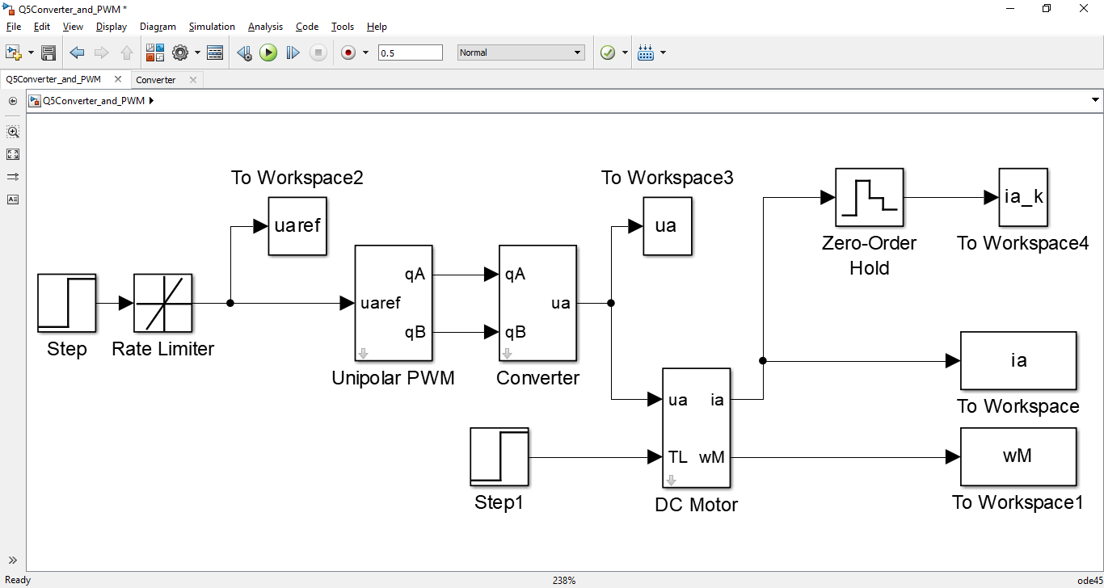

Figure : Voltage Control based Model



Figure : Per unit current and speed

In this simulation, ua is supplied using PWM technique. The Average value of $u_{a}$ is equal to the reference ua. This is achieved by changing the duty cycles dA and dB. The results of current and speed are almost the same as the last section, where an ideal voltage source was used. The current has much more ripple around the mean value as compared to the last case. This is because the current graph has a much thicker line during transition periods. This is when unipolar PWM is adjusting the duty cycles to reach steady state current. The adjustments cause current to oscillate around the mean value. The Moment of Inertia is quite high hence the speed is unaffected by current oscillations. The speed graph is just like the earlier case.

1. **Plotting Armature Voltage and Current**



Figure : Steady state current and speed

The Armature current ia (blue) is a triangular wave because La charges up (current rises) when converter output ua is high; and La discharges (current deceases) when converter output becomes zero. The ua on/off sequence is such that the current rises and drops by equal amounts in steady state. Hence the sampled average current ia_k (red) seems constant.

**Cascaded Control**

1. **Current Control**

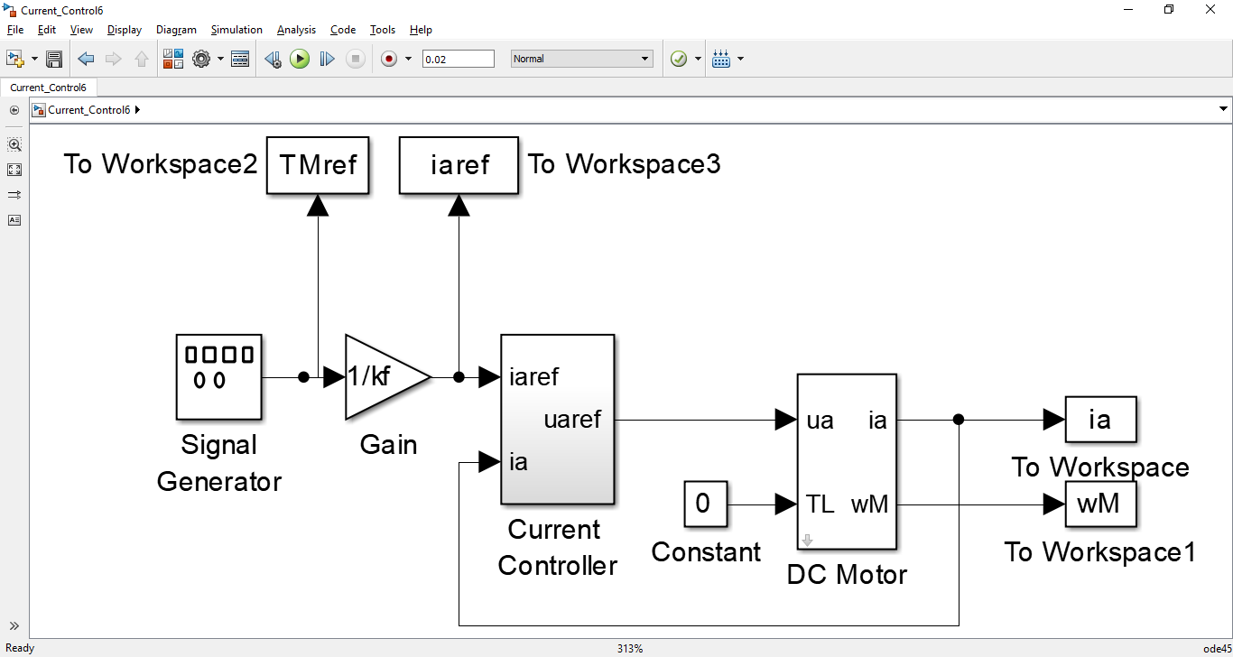

Figure : Current Control Loop Model



Figure : Torque and Speed Response



Figure : Torque Step Response

From the torque step response (Fig. 9), the rise time (from TM = 0.1Nm to TM = 0.9 Nm) is 0.709 ms.

$$H_{c,desired}\left(s\right)=\frac{i_{a}(s)}{i_{a,ref}(s)}=\frac{α_{c}}{s+α_{c}}$$

$$T_{M,ref}(s)=k_{f}i_{a,ref}(s)$$

$$T_{M}\left(s\right)=k_{f}i_{a}\left(s\right);{ T}_{L}\left(s\right)=0$$

$$\frac{T_{M}(s)}{T_{M,ref}(s)}=\frac{α_{c}}{s+α_{c}}$$

$$T_{M,ref}\left(s\right)=\frac{1}{s}$$

$$T_{M}\left(s\right)=\frac{α_{c}}{s\left(s+α_{c}\right)}=\frac{-1}{s+1000π}+\frac{1}{s}$$

$$T_{M}\left(t\right)=-e^{-1000πt}+u(t)$$

The Time Constant of Torque is $\frac{1}{1000π}$. The rise time is $\frac{1}{1000π}*\left(\ln\left(0.9\right)-\ln\left(0.1\right)\right)=$ 0.6994 ms. Hence the simulation result is correct and desired bandwidth has been achieved.

**Cascaded Control**

1. **Transfer Function**

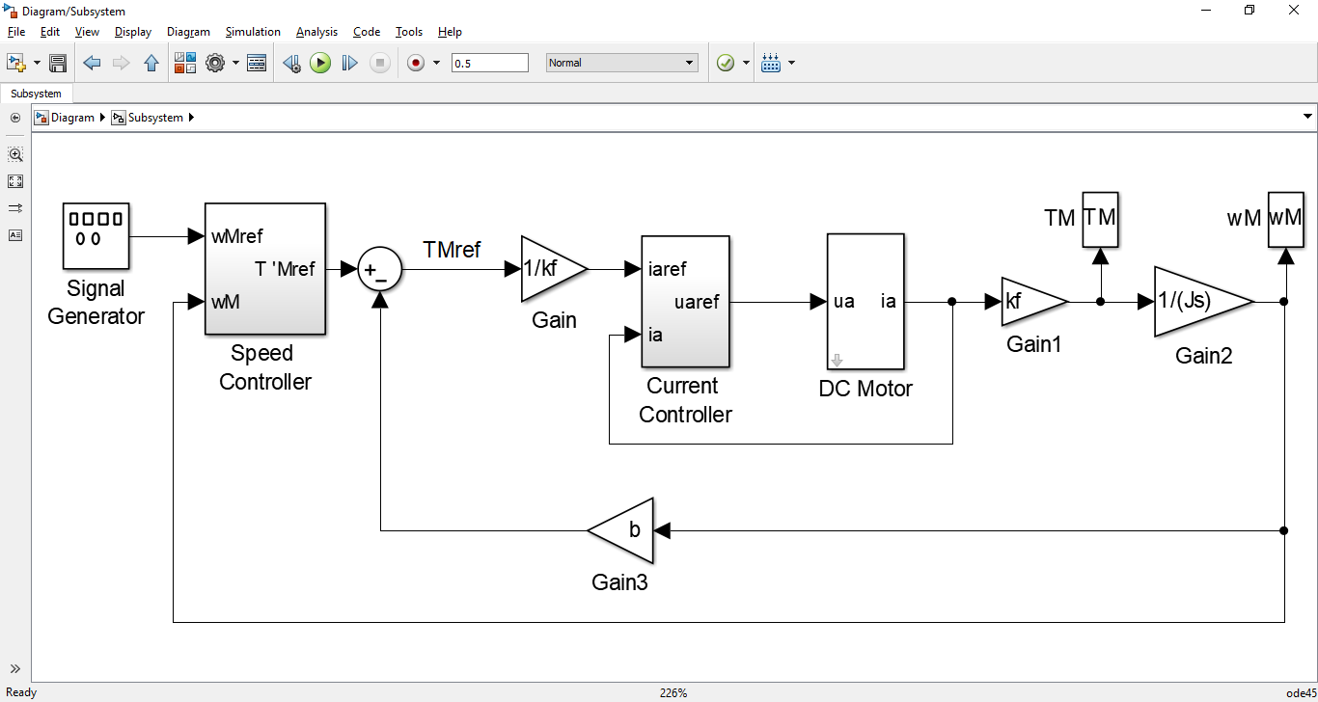

Figure : Simplified Overall System

The Current Control loop has the transfer function

$$H_{c,desired}\left(s\right)=\frac{i_{a}(s)}{i_{a,ref}(s)}=\frac{α_{c}}{s+α_{c}}$$

$$T_{M,ref}=k_{f}i_{a,ref}(s)$$

$$T_{M}\left(s\right)=k_{f}i_{a}\left(s\right);{ T}_{L}\left(s\right)=0$$

$$\frac{T_{M}(s)}{T_{M,ref}(s)}=\frac{α_{c}}{s+α_{c}}$$

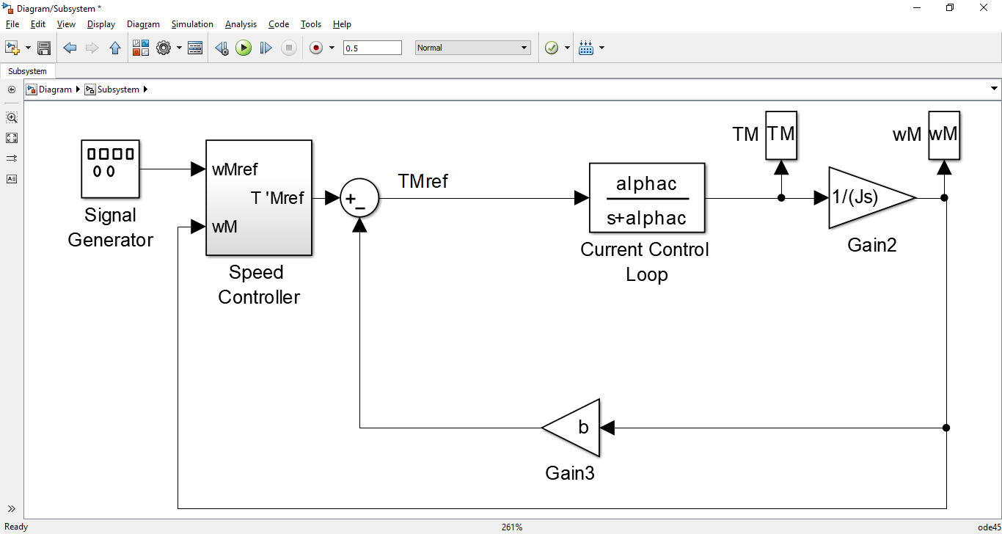

Figure : Simplified Overall System

Assuming ideal torque control,

$$T_{M}\left(s\right)=T_{M,ref}(s)$$

$$\frac{T_{M}(s)}{T_{M,ref}(s)}=1$$

Since,

$$T_{M}\left(s\right)=Jsω_{M}(s)$$

$$H\left(s\right)=\frac{ω_{M}(s)}{T_{M,ref}(s)}=\frac{1}{Js}$$

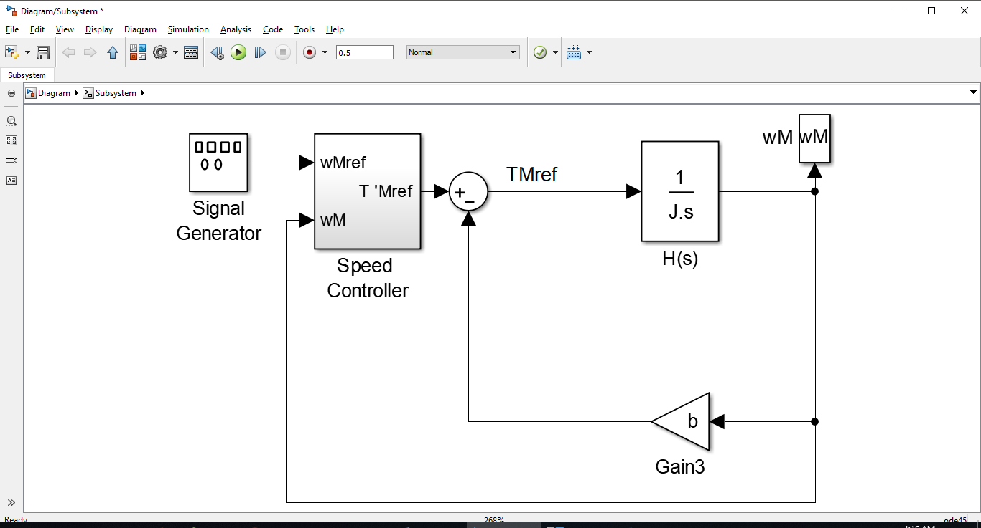

Figure : Simplified Overall System

Using the equation,

$$T_{M,ref}^{'}=T_{M,ref}\left(s\right)+bω_{M}(s)$$

$$G^{'}\left(s\right)=\frac{ω_{M}(s)}{T_{M,ref}^{'}}=\frac{H(s)}{1+bH(s)}=\frac{1}{Js+b}$$

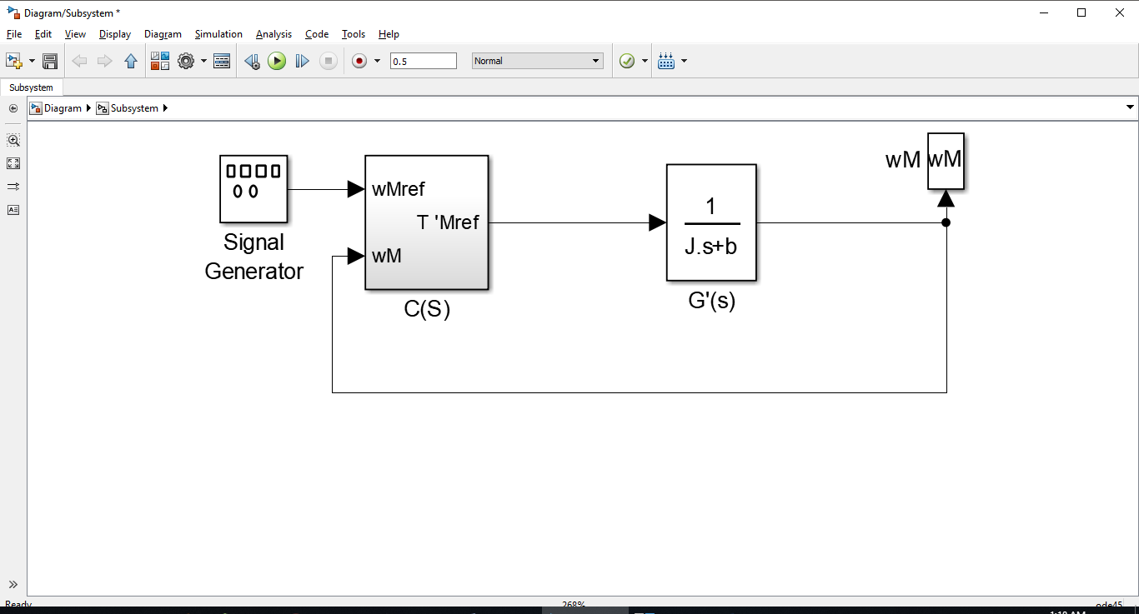

Figure :Simplified Overall System

The speed PI controller has desired transfer function C(s)= $\frac{T_{M,ref}^{'}}{ω_{M,ref}(s)}$. Hence the desired speed control loop transfer function is

$$H_{s,desired}\left(s\right)=\frac{ω_{M}(s)}{ω_{M,ref}(s)}=\frac{C(s)G^{'}\left(s\right)}{1+C(s)G^{'}\left(s\right)}=\frac{α_{s}}{s+α_{s}}$$

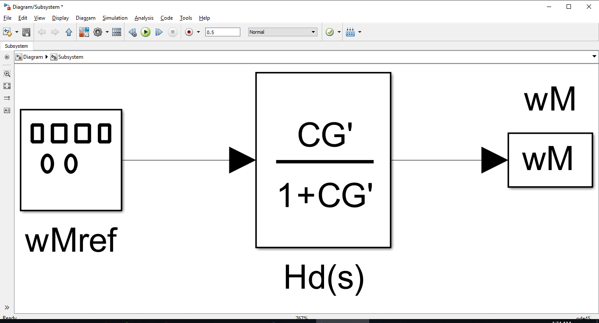

Figure :Simplified Overall System

Hence,

$$\frac{α_{s}}{s}=C\left(s\right)G^{'}\left(s\right)$$

$$C\left(s\right)=\frac{T_{M,ref}^{'}}{ω_{M,ref}(s)}=\frac{α_{s}}{sG^{'}\left(s\right)}=\frac{α_{s}(Js+b)}{s}=α_{s}J+\frac{bα_{s}}{s}=K_{ps}+\frac{K_{is}}{s}$$

At $s= iα_{s}$,

$$|C\left(iα_{s}\right)G^{'}\left(iα_{s}\right)|=1$$

$$|\frac{K_{ps}+\frac{K_{is}}{s}}{\left(Js+b\right)}|=|\frac{K_{ps}\left(iα_{s}\right)+K_{is}}{\left(iα_{s}\right)\left(J\left(iα_{s}\right)+b\right)}|=1$$

$$K_{is}={Jα}_{s}^{2}, K_{ps}={Jα}_{s},b={Jα}_{s}$$

1. **Testing the Model**

$$C\left(s\right)=\frac{T_{M,ref}^{'}}{ω_{M,ref}(s)}=α_{s}J+\frac{bα_{s}}{s}$$

$$α_{s}=\frac{α_{c}}{10}=100π$$

$$b=α_{s}J=0.1 π$$

$$K_{ps}=α_{s}J=0.1 π$$

$$K_{is}=α_{s}^{2}J=10 π^{2}$$



Figure : Speed, Current and Torque Response



Figure : Speed Step Response

From the simulation results, the rise time (from ωM = 0.1 to rad/s = 0.9 rad/s) is 6.4 ms.

The theoretical rise time for ωM is:

$\frac{1}{α_{s}}*\left(\ln\left(0.9\right)-\ln\left(0.1\right)\right)=\frac{1}{100π}*\left(\ln\left(0.9\right)-\ln\left(0.1\right)\right)=$ 6.994 ms

Hence the result matches with the simulation. The speed controller has the desired bandwidth.

1. **Tolerances**



Figure : Speed, Current and Torque Response

The 2-DOF PI controller parameters were designed for the original values of Ra and La. The controllers provided desired closed loop bandwidth using perfect pole-zero cancellation.

$$K_{ic}={L_{a}α}_{c}^{2}, K_{pc}={L_{a}α}_{c}, r={L_{a}α}_{c}-R_{a}$$

With temperature changes, Ra increased; and magnetic saturation decreased La. However, the Speed, current and Torque responses are the same as before. This indicates that the controller is very robust against parameter errors. The PI speed and current controllers have been affected very little by the parameter errors. Although imperfect pole-zero cancellation occurs due to the 2-DOF PI controllers, they are still able to generate precise control commands to track speed, current and Torque references.

1. **Removing Anti-windup from Speed Controller**

The integral action in PI controller is an unstable mode if input error to the controller is large or the input error remains nonzero for a long time. This can cause saturation of controller leading to delayed response. The Anti-windup minimizes performance degradation by accounting for the saturation and reducing integrator input. This prevents the error from accumulating.

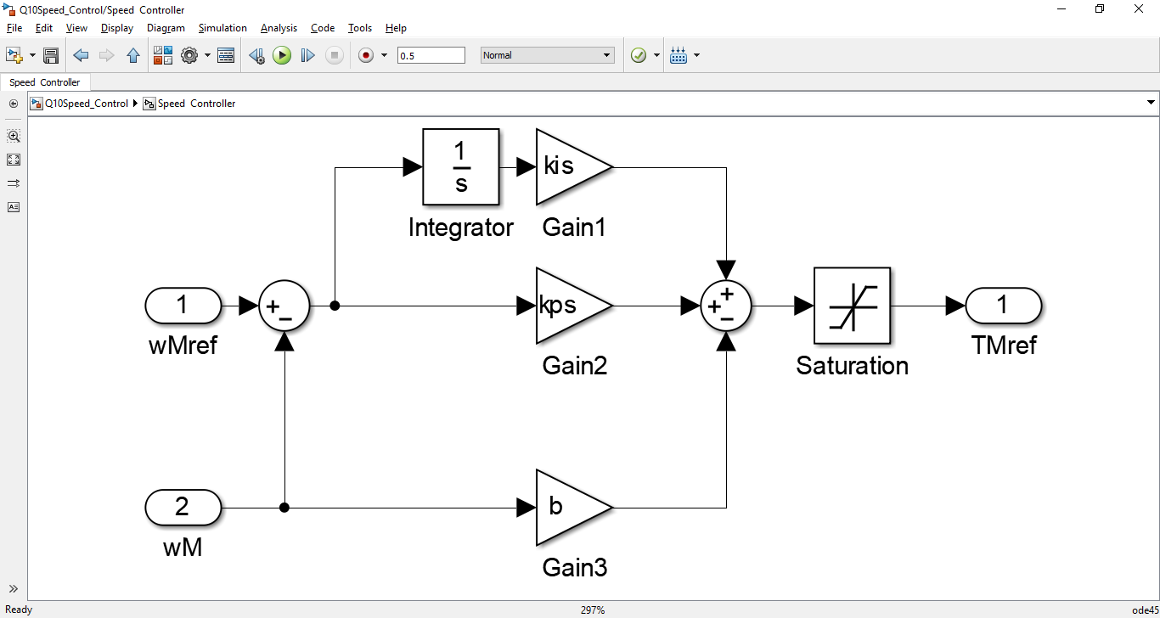

Figure : Speed Controller without Anti-windup



Figure : Speed, Current and Torque Response

When the anti-windup is removed, the integrator is not informed about saturating output signal. Hence integrator effect is not fully implemented in the system, because the output gets saturated. The integrator then keeps accumulating the error over a longer period resulting in a delayed response and overshoots in Torque and current references. High oscillations also occur in the speed, current and torque response due to accumulation of error in integrator. The resulting responses are much different from earlier case with anti-windup.

**Conclusion**

The electromechanical equations of permanent magnet DC motor were used to build a Simulink Model. The discrete time solver was able to generate accurate values for per unit current and per unit speed. The results were verified using steady state analysis of the DC Motor. The transient behavior of the DC Motor was verified using the Laplace transform of characteristic equations. Time domain response obtained using inverse Laplace transform matched with the simulation results. Hence the accuracy of the results was confirmed by mathematical results; in the case of voltage step and Load Torque step application. The response was dictated by machine constants like Resistance, Inductance and Moment of Inertia.

The rate limiter caused a voltage ramp to appear at the Motor input. When it was modeled in Laplace domain, the transient response of this input also matched accurately with the simulation results.

Next, the motor was fed from a four-quadrant DC-DC converter, whose DC-bus voltage was 140 V. The Unipolar PWM generated a Square wave voltage whose average value was controlled using its Duty Cycle. Hence the complete range of voltages from 0V to 140V could be supplied to the motor. The results of current and speed were almost the same as the last experiment, where an ideal voltage source was used. Unipolar PWM duty cycle adjustments cause current to oscillate around the mean value. The Moment of Inertia was quite high hence the speed was unaffected by current oscillations.

Two Degree of Freedom PI Current Controller was used to generate voltage reference from given Torque/ Current reference. Its output then drove the PWM. The current controller parameters were adjusted to get desired bandwidth. The Proportional and Integral gains were set to cause pole-zero cancellation.

The speed controller was cascaded with the current controller so block reduction was used in determining the overall transfer function. After the simplification, the outer loop was solved for Proportional and Integral gains. The desired speed response was checked using measurement of rise time.

With temperature changes, Motor parameters changed. However, the Speed, current and Torque responses are the same as before. This indicated that the controllers were very robust against parameter errors. Although pole-zero cancellation was imperfect, the response was still satisfactory.

When the anti-windup was removed, the integrator was not informed about saturating output signal. The integrator then keeps accumulating the error over a longer period resulting in deterioration of controller performance.